Experiment No.: 5
Title: Apply array methods and object handling; create a cart total calculator with discount logic.
Software/Tools Required: HTML5, CSS3, JavaScript, VS Code, Google Chrome
Theory: Array methods are used to process and manipulate collections of data, while objects store related information as key-value pairs. These concepts can be combined to manage cart items, calculate the total price, and apply discount logic based on predefined conditions.
Output:
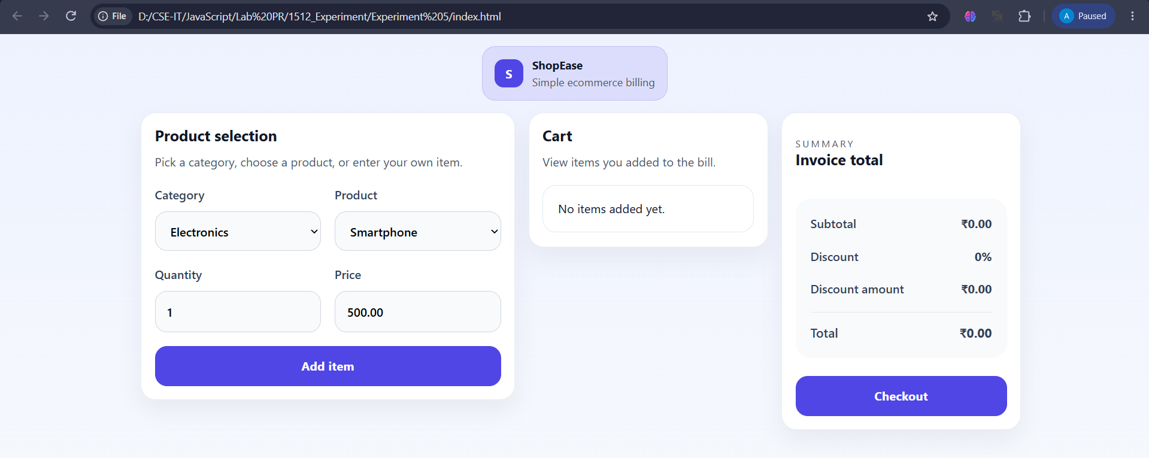
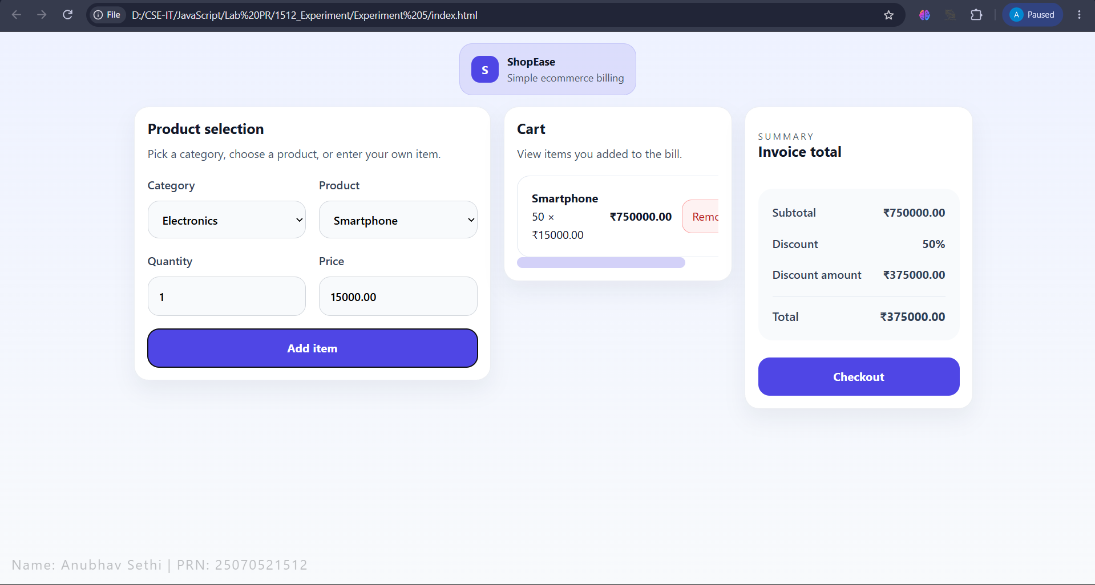
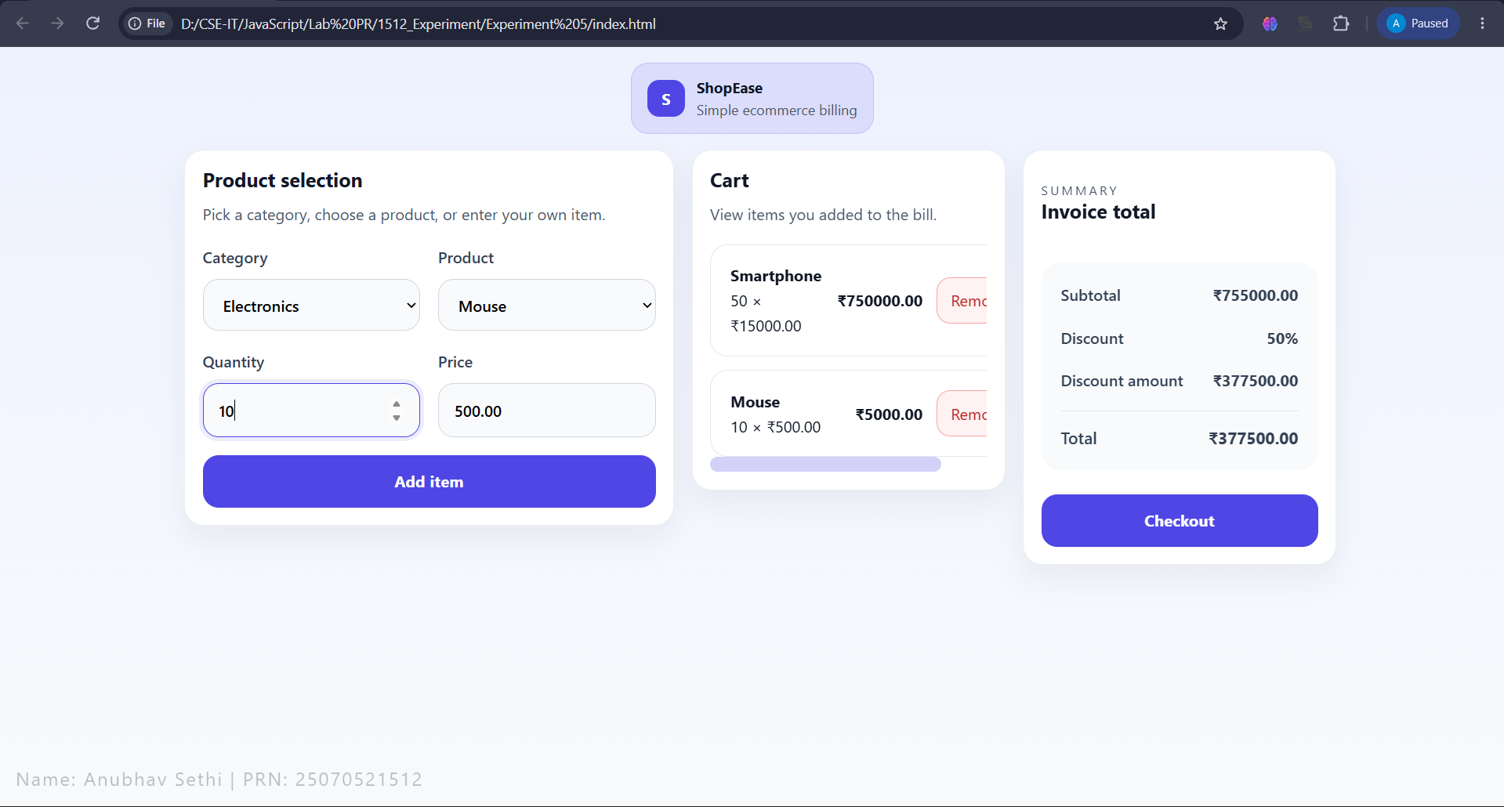
Result: Successfully implemented array methods and object handling to calculate the shopping cart total and apply the appropriate discount.
Conclusion: The practical demonstrated effective use of arrays, objects, and conditional discount logic for cart management.

